UniFlow — Initial Architecture Description

GROUP I
Yohana Mahamat Abdelrassoul | 23/X/23048/PS
Swale Sebabe Abdu | 23/U/23779
Okello Emmanuel Odongo | 23/U/16626/PS
Ainebyona Alvin Police | 23/U/05289/EVE

1. Architecture Overview
UniFlow uses two related parts: the System Under Test (SUT), which implements the three academic workflows, and the AI-native QA Agent, which evaluates the SUT through controlled context and tools. The architecture deliberately keeps authoritative business-rule enforcement inside deterministic application services while giving the agent bounded capabilities for planning, testing and analysis.

2. Initial Component Architecture
High-level flow:
- Users → UniFlow Frontend → UniFlow Backend → UniFlow Database
- QA Engineer → QA Agent → RAG/Knowledge Base + Approved Tools → UniFlow Test Environment → Test Results/Logs
- QA Agent → Defect Report → Human QA Review

3. Main Components
Component | Responsibility
UniFlow Frontend | Provides controlled interfaces for student/administrator interactions with the simulated workflows.
UniFlow Backend | Implements student registration, course registration and timetable generation, including deterministic validation.
Business Rules / Validation | Enforces identity, study-mode, eligibility, prerequisites, course-load, duplicate, timetable, teaching-window and course-frequency rules.
UniFlow Database | Stores synthetic students, programmes, courses, prerequisites, registrations, timetable information and related test data.
QA Agent | Plans bounded QA activities, generates tests, invokes approved tools, analyzes evidence and drafts defect reports.
Knowledge Base / RAG | Stores and retrieves approved requirements, business rules, project documentation and other controlled QA context.
Approved Tools | Expose explicit functions such as search_requirements(), inspect_project(), run_tests(), and create_defect_report().
Test Runner / Results | Executes approved tests and returns structured results, logs and evidence to the agent.
State / Memory | Maintains workflow/session state and one justified persistent-memory mechanism for useful QA context across runs.
Human Review | Reviews consequential outputs such as defect acceptance and any proposed source-code, merge or deployment action.

4. Data and Context Flow
1. The QA Agent receives a bounded QA objective.
2. It retrieves relevant requirements and rules from the controlled knowledge base.
3. It plans a test sequence using only approved tools.
4. The test runner executes the selected tests against the UniFlow test environment.
5. Results and logs are returned to the agent.
6. The agent compares observed results with expected behavior, identifies likely defects and records evidence.
7. If further bounded investigation is justified, the agent may iterate within its configured limits.
8. The final defect report is passed to a human for review; the agent does not directly change the system.

5. Agentic Loop and Stop Conditions
The QA Agent will use a bounded multi-step loop: retrieve context → plan → call an approved tool → inspect result → decide whether another approved step is necessary → stop/report. The loop will have explicit iteration and tool-call limits. It must stop when the test objective is satisfied, when the evidence is sufficient, when the configured limit is reached, or when human intervention is required.

6. Security and Control Design
- Use synthetic/authorized data only.
- Keep secrets outside the agent's context and accessible tool paths.
- Separate the test environment from production.
- Use explicit tool schemas and allow-lists rather than unrestricted execution.
- Log tool calls, test executions, results and important agent decisions.
- Require human approval for consequential actions.
- Keep Git history and project tasks traceable through the team's repository and task-management workflow.

7. Initial Architecture Diagrams
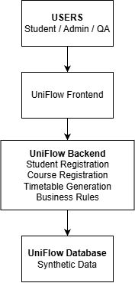

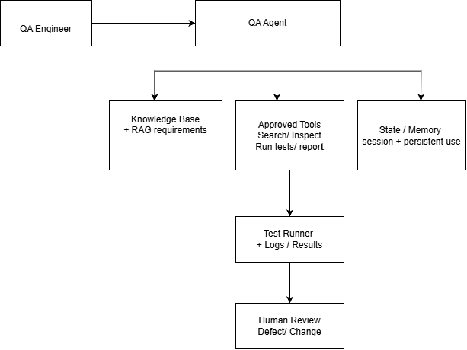

8. Planned Evolution Beyond Week 1
Later iterations will add the concrete implementation of the foundation-model integration, prompt versioning and tests, retrieval evaluation, explicit tools, bounded agent loop, state/persistent memory, an external integration or MCP-style interface, broader evaluation scenarios, hardening, and reproducible deployment. Retake management will be specified as a later requirement rather than being prematurely fixed in this initial architecture.

